|  |
| --- |
| INSE 6260 |
| Project Development Plan |
| Transit Electrification Simulation Software |
| **Team Members:**  **Yu Jin (23753034)**  **Gurpreet Kaur (40106011)**  **Daniel(A) Zakerifar (40054453)** |
|  |

|  |
| --- |
| Concordia University | Faculty of Engineering & Computer Science  Concordia Institute for Information Systems Engineering |

**10-02-2020**

# **1.** **Introduction**

## **1.1.Objectives of the project**

We will be developing the software that will help the STM Team of Montreal to plan the electrification of bus route 211 in their system i.e. from Lionel-Groulx to Sainte-Anne/Terminus McDonald. The software will provide the optimal number of buses and chargers to be obtained in order to electrify the bus route 211.

## **1.2. Scope statement**

The scope of the project is to develop the simulation software that will provide the suggestion to user/STM Manager about how many numbers of buses, chargers will be required for the transit electrification of bus route 211. Also, users will have facility to provide input like which manufacturer of the charger, which type of battery should be there in the buses along with the price.

## **1.3. Stakeholder profiles**

Gurpreet Kaur – Responsible for Project development, testing and documentation.

Daniel – Responsible for project development, testing and documentation.

Professor Chun Wang – He is a system matters experts. Provide inputs to project team members (Noble Team) regarding project requirements. He is the owner of the project.

# **2.** **Product and deliverables**

Product - We will be developing the software that will assist the STM team to electrify the bus route 211 i.e. from Lionel-groulx to McDonalds.

Software Requirements Specification (SRS) - 3 February, 2020

Software Project Development Plan - 10 February 2020

Software Quality Assurance Plan - 3 March,2020

SDS - 10 March 2020

Software System - 7 April 2020

Final Project Report - 7 April 2020

# **3.** **Project interfaces**

An interface is defined as a point of connection between entities working on a common project. It is the process designed to provide a method to formally document and track the exchange of information between project participants and to monitor the performance of all participants in making available the required information.

The process involves

• Identification and recording an interface

• Creating an interface agreement

• Agreeing / Resolving Conflict

• Monitoring the status

• Reporting the status

• Closing the interface agreement

# **4.** **Software development process**

For this project we will be using the Waterfall model to carry out all the project related activities. It is a sequential design process in which progress is seen flowing downwards.

The stages of waterfall model are as below:

Requirement Phase: In this phase we will be doing requirement gathering. All the requirements of the system to be developed are captured in this phase and documented in the requirement specification document.

System Design: Software requirements gathered in the first phase will be analysed here and design of the product will be produced.System design helps in defining the overall system architecture.

Implementation Phase: With the help of design phase inputs, we will be developing the software in smaller chunks and the functionality of each chunk is tested, known as unit testing.

Integration and Testing: After the development of each unit, they are integrated as a system in this phase. Post integration testing of the whole system is done in order to find out any vulnerabilities.

Deployment of System: Once the testing is done, the product will be released in the market or make it available for the users.

Maintenance: In this phase complaints faced by the users will be removed.

# **5.** **Project process activities and schedule**

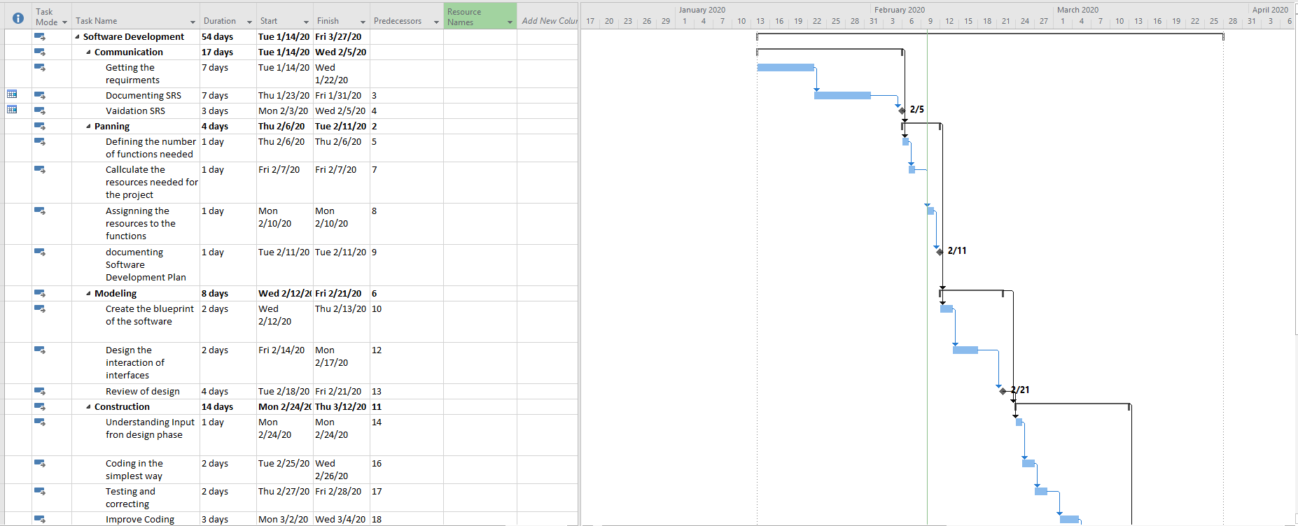

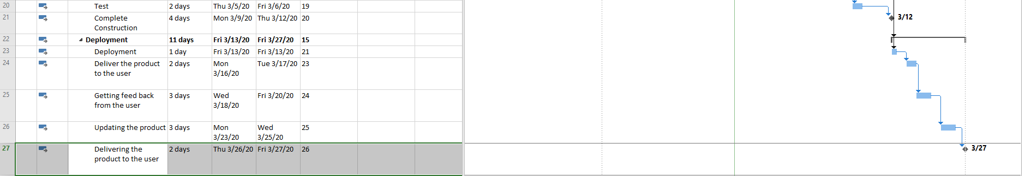

# **6.** **Project milestones**

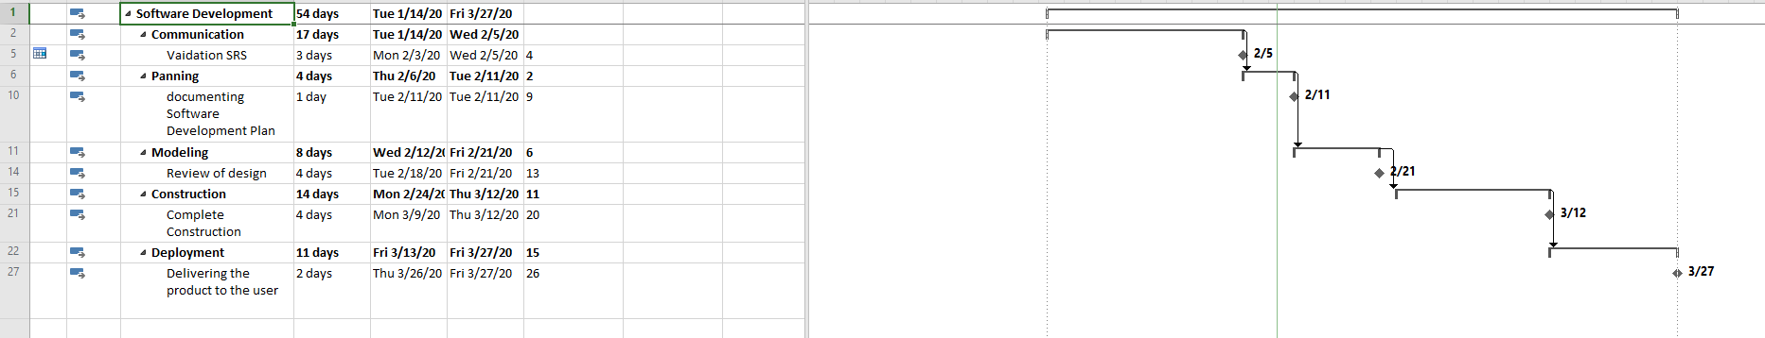

# **7.** **Project team organization**

System Matters Expert - Professor Chun Wang.

|  |  |  |
| --- | --- | --- |
| Project Teams | Team Member | Role |
| Project managing team | Gurpreet kaur, Daniel | Managing the project from beginning until project completed |
| Software Engineer Team | Gurpreet kaur, Daniel | Requirement gathering,system designing,development, documentation |
| Quality Assurance Team | Gurpreet kaur, Daniel | Prepare SQA plan for the project, Participate in the development of the project software process description, Review software engineering activities to verify compliance with the defined software process |
| Quality Control Team | Gurpreet kaur, Daniel | Technical Reviews, Code inspection, Testing ,Formal verification |

# **8.** **Development facilities**

MS Project(Whole Project)

MS Office(Whole Project)

Eclipse.(Whole Project)

Windows>7(Whole Project)

2 PCs or Laptops(Whole Project)

# **9.** **Development risks**

Misunderstanding of requirement: If there is any problem in requirement gathering then the end product will be wrong and the whole project has to start from scratch.

Less experience in design development: Understand the project requirement and then use that information in order to create the project design as it is a backbone of the project.

## Estimation and scheduling: Estimation of resources and time required to complete the project also requires proper planning and skills.

## Scope Creep: If the requirements will keep on changing, then to meet the scope of the project within the specified time limit will become difficult.

Broken down our devices or losing memory.

## 

# **10.** **Control methods**

We will be using Earn value and Gantt charts for controlling the progress of time, cost and scope.

We will be using SQAP for controlling the progress of quality of the product.

Function points.

Review efforts.

Error density metrics.

Error Severity metrics.